1. Summary statistics across Market Segment

# 1. Average ADR by Market Segment

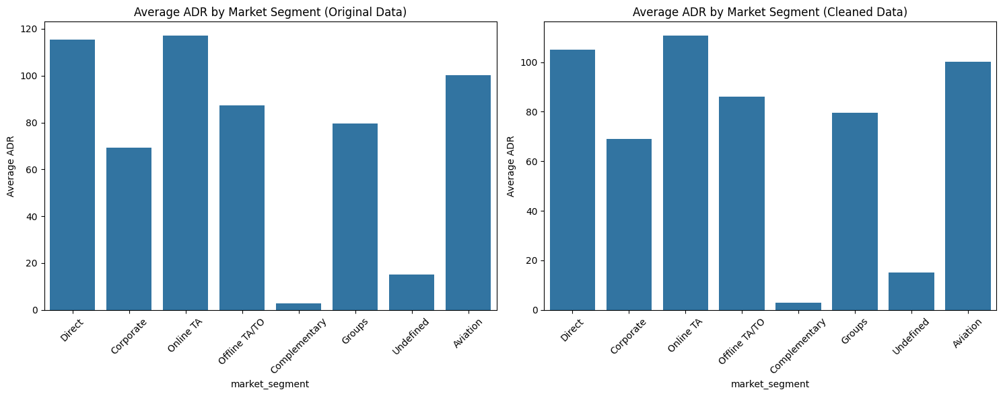

**ADR trends analysis**

The chart reveals key insights into market segment performance. Direct, Online TA, and Aviation segments have the highest ADR, indicating they are high-revenue sources worth prioritizing for marketing and revenue optimization.

In contrast, Complementary bookings generate minimal revenue, thus their volume should be carefully monitored to ensure they align with business objectives.

**Monthly ADR Trends by Year (Using Time-series chart)**

This visualization will aid us in better plotting ADR by month to detect seasonal fluctuations, knowing not just which segments are profitable, but when they are most profitable.

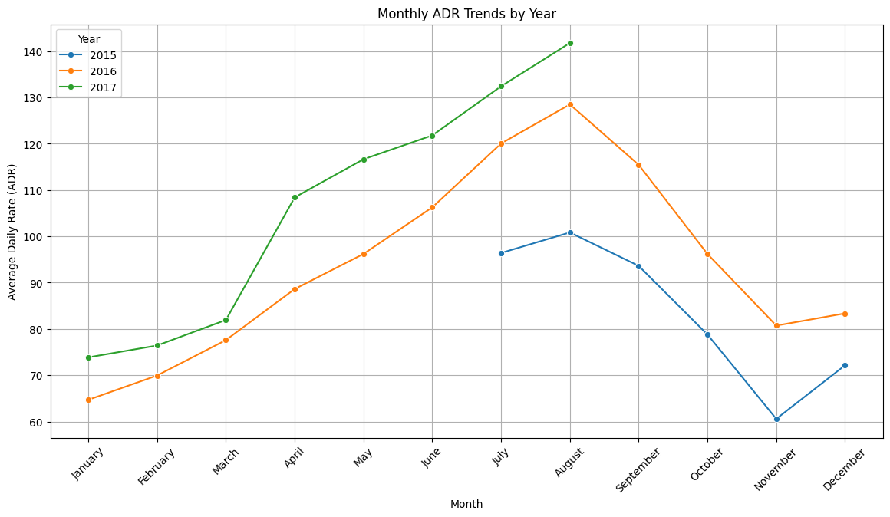

The time-series chart illustrates monthly ADR trends for the years 2015, 2016, and 2017, revealing clear seasonal patterns. For all three years, ADR tends to rise steadily from January through the summer, peaking around July and August, particularly in 2016 and 2017. This implies a strong demand during the middle of the year, likely in line with the vacation or travel seasons in Algarve, Portugal.

After August, ADR drops sharply for all years, showing a notable decline in the fall, especially in September and October. This suggests off-peak periods where demand lowers.

**ADR Trends by Segment and Month (Using heatmap)**

We will generate a heat map of ADR across both month (arrival_date_month) and market segment (market_segment) to better understand which market segments have greater ADR during particular months with the goal to reveal seasonal behavior within distinct segments.

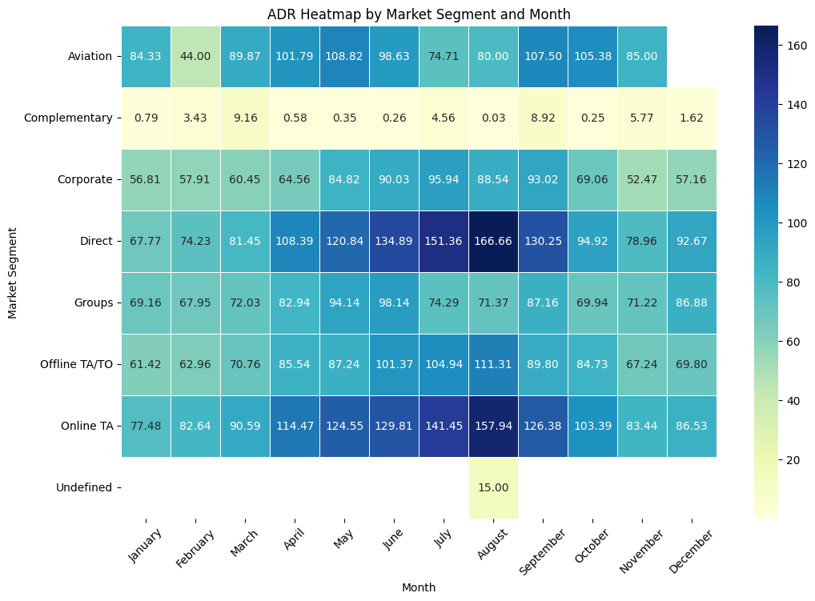

Focusing on detecting the seasonal trends for our top three highest ADR, Direct, Online TA and Aviation segments. On the whole, the months of July and August have seen the highest ADR for both Direct and Online TA, which adds the most value during the travel season. In the meantime, Aviation peak points extend from September to October.

**Summarize**

_ Highest ADR Segments: Direct, Online Travel Agencies (TA), and Aviation generate the most revenue.

_ Seasonal Patterns:

* Peak ADR: July-August for Direct & Online TA, indicating strong vacation season demand.
* Aviation Segment Peak: September-October, extending beyond the general peak travel season.
* Low ADR: Fall and early winter months, especially post-October.

**Recommendation**

* Dynamic Pricing: Focus on surge pricing during peak months for Direct and Online TA segments. Offer early-bird discounts to encourage bookings during off-peak seasons.
* Aviation Focus Campaign: Extend promotions targeting Aviation travelers into September-October to maximize revenue in this period.

# 2. Cancellation Rate by Market Segment

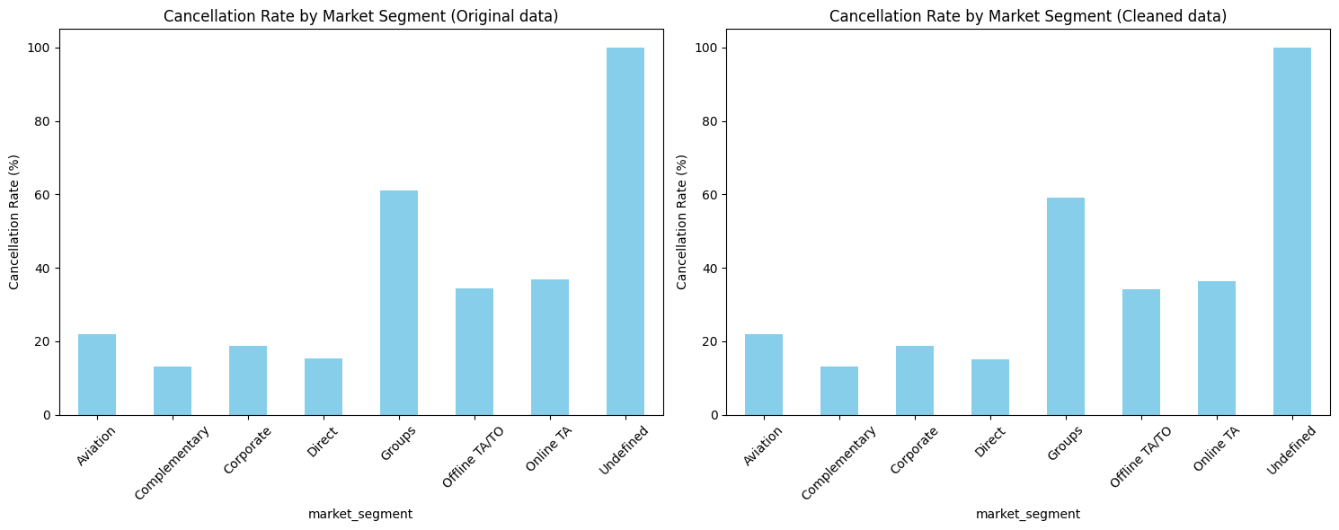

**Cancellation Rate by Market Segment Analysis:**

In this chart, the "Undefined" segment shows the highest cancellation rate, near 100%. However, since we have little information about how this "Undefined" segment is defined or handled, there fails to be much we can do to address it.

The "Groups" sector has the second-highest cancellation rate, around 60-70%, indicating a consistently higher likelihood of cancellations in group bookings.

In comparison to the two mentioned groups, the "Aviation," "Direct," "Corporate," and "Offline TA/TO" segments show comparatively low and stable cancellation rates.

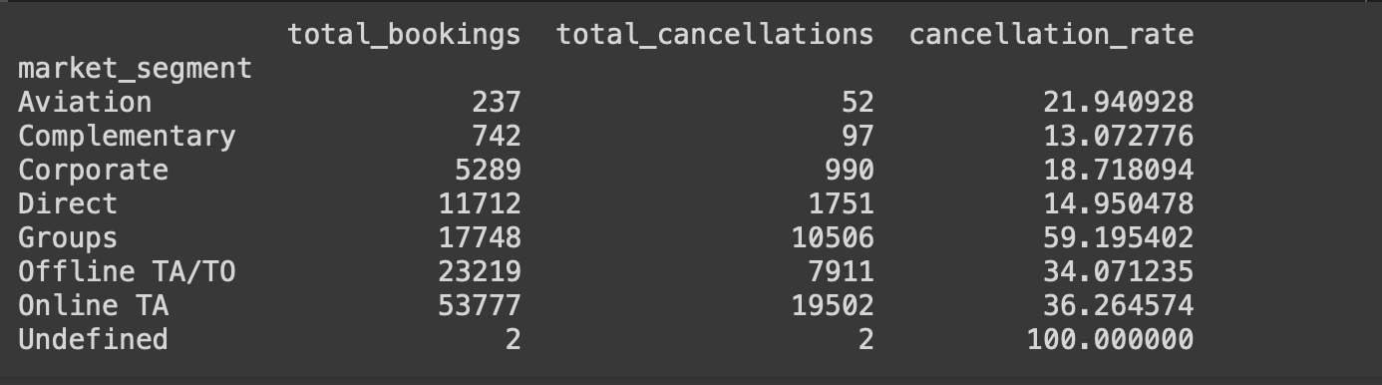

"Groups" and "Online TA" are key areas of concern, with high cancellation rates. This could suggest that over half of the bookings in these two segments get canceled, reflecting either a behavioral pattern or an operational issue that requires additional investigation.

**Summarize**

_ Cancellation Rates by Market Segment

_ Highest Cancellations:

* "Undefined" (near 100% — likely a data issue).
* Groups (60-70%) and Online TA segments show significant cancellation behavior.

**Recommendation**

_ Cancellation Reduction Strategy:

* Implement stricter cancellation policies or non-refundable options for Group bookings.
* Offer personalized retention offers to Online TA customers with higher cancellation tendencies (e.g., small perks for holding their booking).

# 3. Lead time by Market Segment

## a) Mean lead time

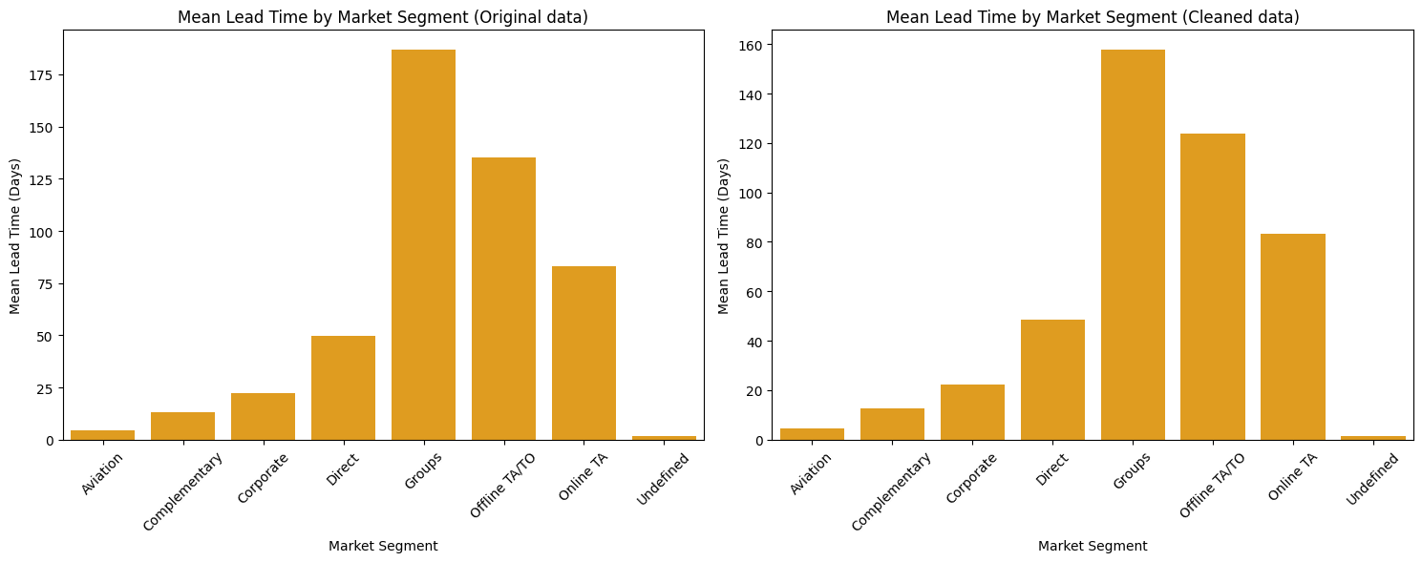

**Mean Lead Time Analysis:**

The mean lead time for "Groups" is the largest, indicating that reservations for groups are frequently booked long in advance. Direct bookings likewise have a large lead time, suggesting that direct bookers typically have a long planning period.

Low lead periods in the "Corporate" and "Aviation" segments imply that these reservations may be more spontaneous or reactive.

## b) Median lead time:

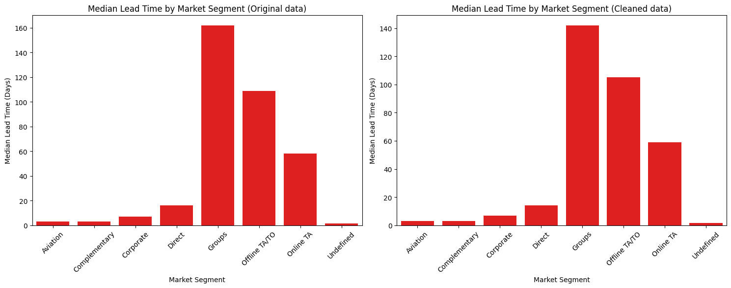

**Median lead time analysis:**

The data highlights distinct patterns in booking behavior by market segment. Groups and TA/TO segments require long lead times, indicating potential outliers, as their lead times are disproportionately high compared to others.

In contrast, "Direct" and "Corporate" bookings have shorter lead times, reflecting spontaneous or urgent travel. Individuals or last-minute travelers who do not require agents are more likely to make direct reservations, whereas corporate reservations could be made for brief, transient business trips.

c) Mode lead time:

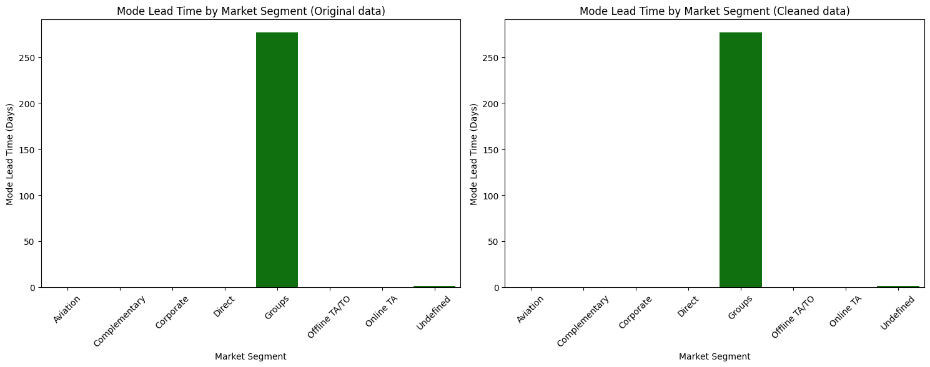

**Mode lead time analysis:**

The mode lead time provides valuable insights into booking behaviors and patterns within different market segments. This chart indicates that "Group" reservations tend to be planned and booked far in advance, whereas bookings from other market segments (like "Direct" or "Corporate") are typically made with little to no lead time.

**Summarize**

_ Lead Time by Market Segment

* Long Lead Times: Groups and Direct segments.
* Indicates high planning periods—Group reservations likely require long coordination efforts.
* Short Lead Times: Corporate and Aviation, signaling more spontaneous or business-driven bookings.

**Recommendation:**

_ Optimizing Lead Time:

* Encourage Group bookings with early booking discounts.
* Leverage short lead times for Corporate/Aviation by offering last-minute deals or bundled offers (e.g., transport + hotel).

II. **Summary statistics across Distribution Channel**

# 1. Average ADR for Distribution Channel

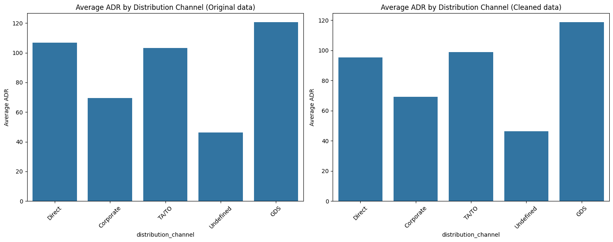

**Average ADR by Distribution Channel Analysis:**

According to this figure, hotels generate the most revenue per room via the GDS channel, with direct and TATO bookings coming in second and third. In contrast, bookings through Corporate and Undefined channels result in lower revenue.

# 2. Cancellation Rate by Distribution Channel

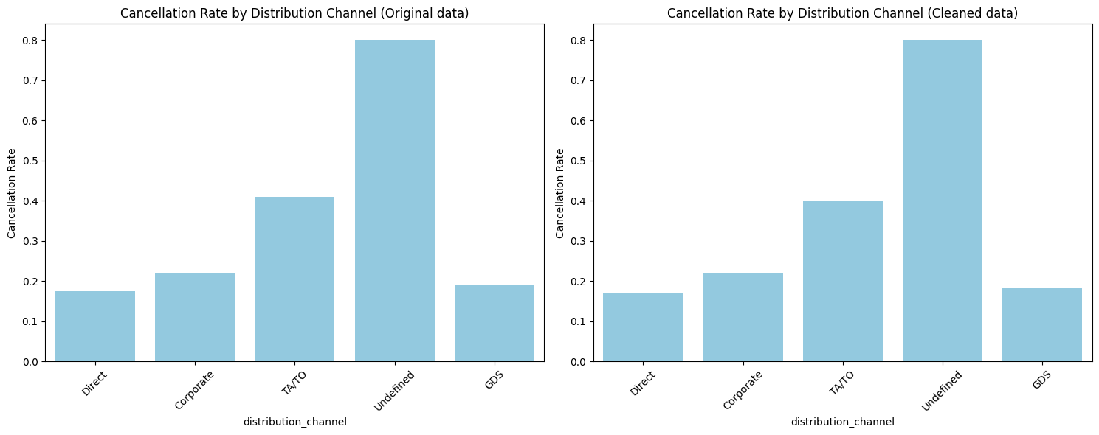

**Cancellation rate by Distribution channel analysis:**

The chart provides insights into the cancellation rates of hotel bookings across different distribution channels. The channel labeled as "Undefined" consistently shows the highest cancellation rate, hinting potential issues or unreliability with bookings coming from this source. The TA/TO channel also has a relatively high cancellation rate, recommending that more work may be necessary to lower cancellations.

Conversely, the Direct and GDS channels exhibit the lowest cancellation rates, making them the most reliable sources for bookings.

This means that in order to maximize booking reliability, hotel management should continue to promote stable channels like Direct and GDS while concentrating on addressing the high cancellation rates in the Undefined and TATO channels.

# 3. Lead Time by Distribution Channel

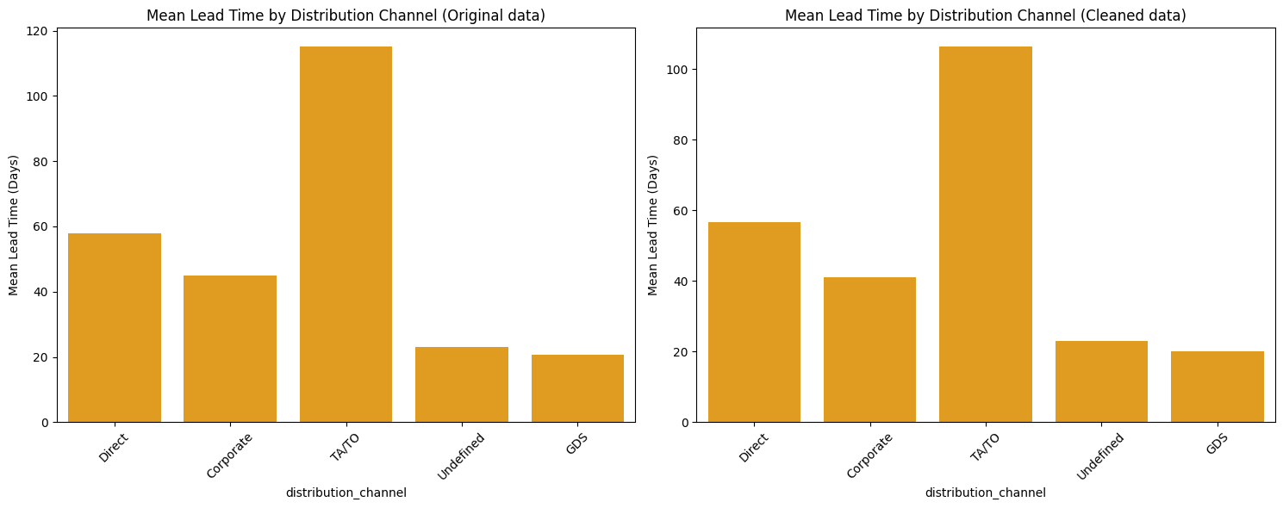

**Mean lead time by Distribution channel analysis:**

The chart illustrates the mean lead time (in days) for hotel bookings across different distribution channels. Customers that book through the TATO distribution channel typically plan their stays well in advance, as evidenced by the channel's significantly longer mean lead time.

The GDS and Undefined channels have much shorter lead times, indicating that customers using these channels tend to book closer to their actual stay dates.

<https://www.bookingninjas.com/blog/cancellation-rate-in-the-hospitality-industry>

The lead time refers to the number of days between the date a reservation is made and the date of arrival at the hotel. In essence, it measures how far in advance a guest books their stay. Understanding lead time helps hotels anticipate booking patterns, prepare for peak seasons, and maximize room availability.

Average Daily Rate (ADR) is the average revenue a hotel earns per available room, a key indicator of how much guests are paying for a hotel room on average and is directly linked to a hotel’s pricing strategy.